
King Saud University
College of Computer and Information Sciences
Department of Information Technology
IT 362 - Data Science Principles
1Semester 1447 H

Cross-Domain Performance of Hate Speech Detection Models
(Modelling and Communication Phase)
Section # 80658
ID Number | Student Name
444200109 | Raghad Omar Al-Quwaider
444200530 | Renad Alowais
444201168 | Shahad Alotaibi
444201206 | Zuhd Ibrahim
444200371 | Ghada Alqahtani

Supervised by: Dr. Abeer Al-Dail

ABSTRACT
This comprehensive project analyzes and studies the behavior of hate speech and toxicity across major social media platforms: Reddit, Twitter, and YouTube. The work addresses two primary research questions: Is there a statistically significant difference in mean toxicity scores between these platforms? And do the toxicity scores influence the level of content engagement?
The methodology utilized two core tasks in Phase 3. The first was Statistical Hypothesis Testing using Welch's t-test, corrected by Bonferroni Correction, to compare mean toxicity scores. The analysis revealed a statistically significant difference in the level of toxicity only between Reddit and Twitter. The second task was a Regression Analysis to predict user Engagement using features including toxicity score and platform type. Three models were developed (Linear, Ridge, and Decision Tree), and the Decision Tree Regressor was selected as the best-performing model based on the lowest MSE. Model interpretations revealed that the overall toxicity score has a slight negative association with engagement, while other factors like negative word count are positively correlated with user interaction. The models, however, show limited explanatory power, suggesting that engagement is influenced by external factors beyond measured toxicity.

TABLE OF CONTENTS
Section | Title | Page No.
1.0 | Introduction | 4
1.1 | Project Background and Objectives | 4
1.2 | Report Structure | 4
2.0 | Data Review & Preprocessing | 4
2.1 | Data Description and Features | 4
2.2 | Preprocessing Steps | 5
3.0 | Exploratory Data Analysis (EDA) | 5
3.1 | Visualizations and Key Insights | 5
4.0 | Modelling and Analysis (Phase 3) | 5
4.1 | Hypothesis Testing: Cross-Platform Toxicity Comparison | 6
4.1.1 | Statistical Methodology | 6
4.1.2 | Results and Findings | 6
4.2 | Regression Task: Predicting Engagement | 7
4.2.1 | Model Comparison and Evaluation | 7
4.2.2 | Best Model Selection and Interpretation | 7
5.0 | Logbook Summary (Technical Decisions) | 7
6.0 | Results and Discussion | 8
7.0 | Conclusion and Future Work | 8

1.0 Introduction
1.1 Project Background and Objectives
The proliferation of online content has led to a critical challenge concerning hate speech and toxicity across diverse social media platforms, including Reddit, Twitter, and YouTube. Understanding the cross-domain behavior of toxic content is crucial. This project, titled Cross-Domain Performance of Hate Speech Detection Models, utilizes statistical modeling to analyze toxicity characteristics and achieve two main objectives:
1-Determine if there is a statistically significant variation in the mean toxicity score across different social media platforms.
2-Investigate the relationship between toxicity severity and user engagement and determine if the toxicity score is a meaningful predictor of user interaction.
1.2 Report Structure
This report details the full data science process, covering data collection, preprocessing, exploratory analysis, and Phase 3 modeling. The structure includes an analysis of statistical Hypothesis Testing and Prediction Modeling, followed by a summary of key findings, technical challenges, and conclusions.

2.0 Data Review & Preprocessing
2.1 Data Description and Features
The analysis utilizes a multi-domain hate-speech dataset, which aggregates cleaned content from Reddit, Twitter, and YouTube. The main variables used for the analysis were:
Toxicity Score (0–1): A numeric, continuous feature representing the predicted severity of toxic content.
Platform: A categorical variable identifying the content source
Engagement (0–1): A numeric outcome representing user interaction (e.g., likes, replies, views).
Auxiliary Features: word_count and negative_word_count were included as predictors in the regression task.
2.2 Preprocessing Steps
The data underwent the following preprocessing steps prior to modeling:
Missing Values: Rows containing missing values were removed. The Logbook further notes that non-numeric values in the Engagement column were coerced and dropped.
Normalization: All numeric fields (including toxicity_score and Engagement) were normalized to a range between 0 and 1.
Encoding: The categorical Platform variable was encoded to a numerical format. For the regression analysis, this involved creating platform dummy variables (e.g., Platform_Twitter) to estimate the independent effect of each platform.
3.0 Exploratory Data Analysis (EDA)
3.1 Visualizations and Key Insights
Toxicity Score Distribution: The box plot visualization across platforms showed that toxicity scores are lowest on Reddit, highest/spread on Twitter, and moderate on YouTube.
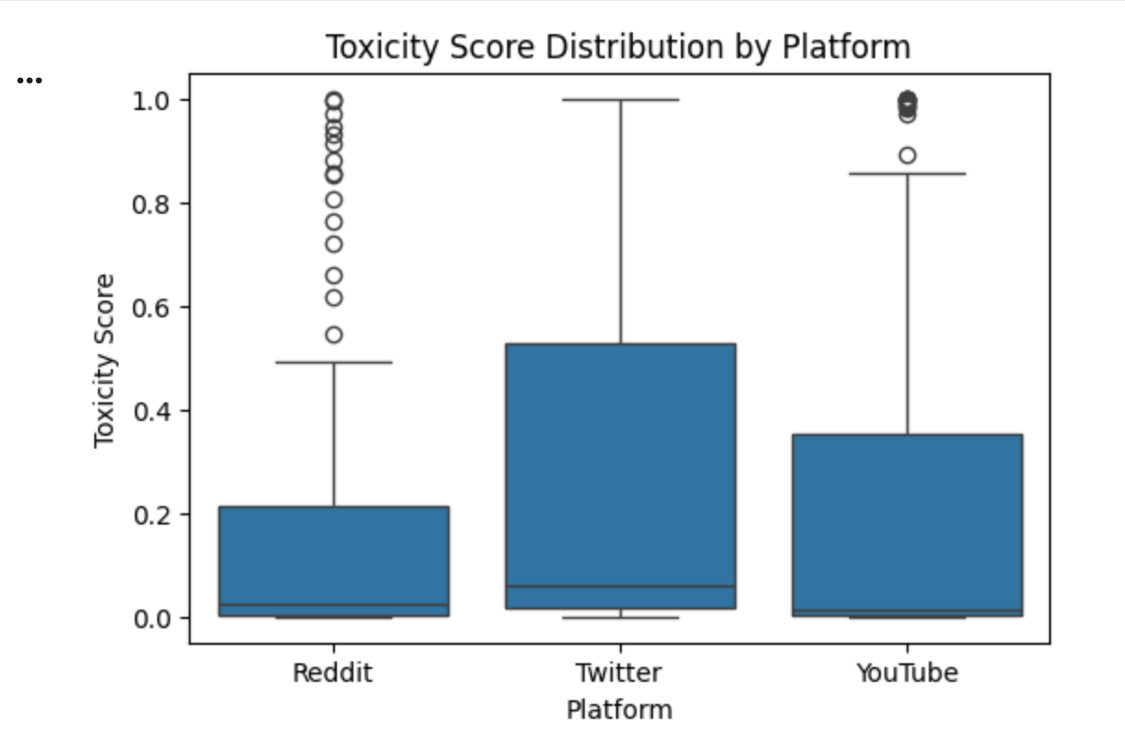
Engagement Distribution: Engagement scores were heavily skewed toward zero across all platforms, with many outliers indicating posts with viral interaction.
Correlation: Preliminary analysis revealed that the relationship between toxicity and engagement is weak or near zero, indicating that toxicity alone is not the primary driver of interaction.
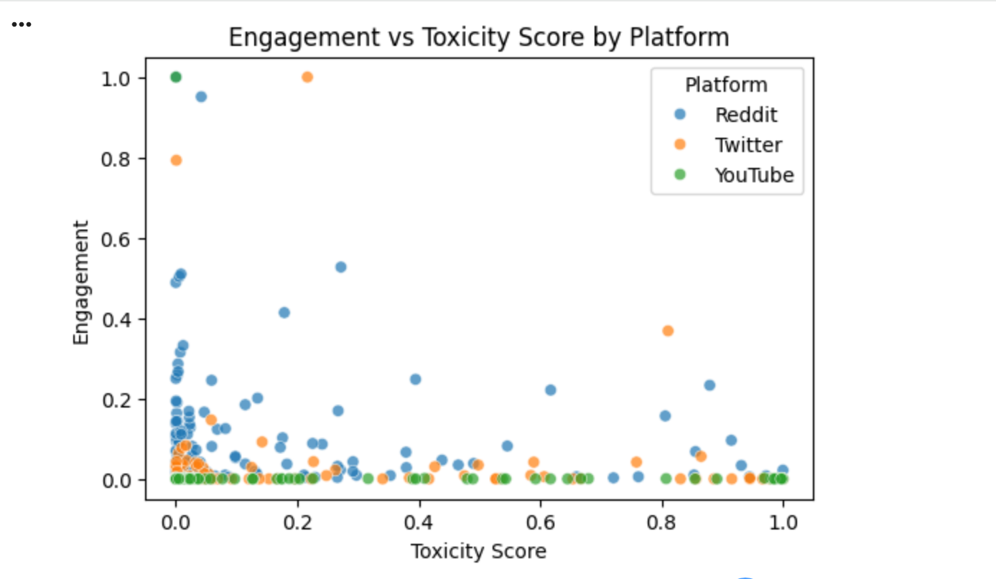

4.0 Modelling and Analysis (Phase 3)
The modelling phase addressed both core research objectives using statistical inference (Hypothesis Testing) and predictive modeling (Regression).

4.1 Hypothesis Testing: Cross-Platform Toxicity Comparison
The goal was to statistically assess differences in mean toxicity scores across the three platforms.
4.1.1 Statistical Methodology
Preliminary Tests: Initial tests (Shapiro-Wilk for Normality and Levene's Test for Equal Variances) were conducted to assess the suitability of parametric tests.
Overall Test (ANOVA): A One-Way ANOVA test was used to initially check if any difference existed across the means.
Pairwise Comparison: Pairwise Welch t-tests were performed due to the high likelihood of unequal variances.
Error Control: A Bonferroni Correction was applied to the pairwise p-values to control the Type I error rate associated with multiple comparisons ($\alpha$ was adjusted to $0.0167$).
4.1.2 Results and Findings
Table 1: Pairwise Welch t-Test Results (Bonferroni Corrected).
Comparison | t-statistic | p-value | Decision (at α = 0.0167)
Reddit vs Twitter | -2.7970 | 0.005816 | Significant difference
Reddit vs YouTube | -1.3412 | 0.181532 | NOT statistically significant
Twitter vs YouTube | 1.3283 | 0.185752 | NOT statistically significant

Conclusion: The statistical analysis confirmed that mean toxicity significantly differs across platforms. Crucially, the difference is meaningful only when comparing Reddit and Twitter.

4.2 Regression Task: Predicting Engagement
The goal of this regression task was to predict the continuous Engagement score using toxicity severity and other features.
4.2.1 Model Comparison and Evaluation
Models: The comparison included a Baseline Model (predicting the mean), Linear Regression, Ridge Regression (regularized model), and Decision Tree Regressor (non-linear patterns).
Evaluation Metrics: Model selection was based on the lowest Mean Squared Error (MSE), with the score used as a measure of variance explained.
Table 2: Comparative Performance Metrics of Regression Models
Model | MSE (Mean Squared Error) | R2 Score
Baseline Model | 0.0381 | -0.0166
Linear Regression | 0.0358 | 0.0430
Ridge Regression | 0.0357 | 0.0459
Decision Tree Regressor | 0.0065 | 0.9358

4.2.2 Best Model Selection and Interpretation
Best Model: The Decision Tree Regressor was selected as the best-performing model, achieving the lowest overall MSE and the highest.
Key Findings:
- Toxicity Score: Showed a slight negative correlation with engagement in linear models.
- Negative Word Count: Exhibited the strongest positive correlation, suggesting that while overall toxicity might not boost interaction, aggressive language (or "negative" sentiment) often does.
- Model Performance: All prediction models demonstrated that toxicity has a weak relationship with engagement, and remained low, indicating that engagement is noisy and unpredictable based on these features alone.

5.0 Logbook Summary (Technical Decisions)
The comprehensive Logbook Report, submitted as a separate deliverable, documents all technical decisions and challenges during Phase 3:
Preprocessing Rationale: Non-numeric values in the Engagement column were handled using to_numeric(coerce) to ensure data quality, followed by the use of dummy variables for platforms.
Statistical Control: The decision to use Bonferroni Correction for pairwise t-tests was critical for maintaining control over the Type I error rate when conducting multiple comparisons.
Model Selection Criteria: The reliance on the lowest MSE was the primary metric for selecting the best prediction model (Decision Tree Regressor).
Overfitting Mitigation: Limiting the depth of the Decision Tree Regressor was a conscious decision to manage the risk of overfitting non-linear patterns.

6.0 Results and Discussion
The combined analysis of hypothesis testing and regression confirms the project’s main insights:
Platform Difference: Toxicity significantly differs across platforms, but statistical testing shows this difference is meaningful only between Reddit and Twitter.
Engagement Drivers: Toxicity severity does not increase engagement. The weak correlation suggests that engagement is driven by factors beyond mere toxicity, such as content style and community norms. The models indicate that while higher toxicity generally correlates negatively, other forms of negative language can still drive interaction.

7.0 Conclusion and Future Work
7.1 Conclusion
This study successfully leveraged both statistical inference and machine learning to analyze cross-platform hate speech behavior. We concluded that the toxicity profiles differ primarily between Reddit and Twitter, but the severity of toxicity alone is not a strong driver of user interaction. These findings emphasize that content moderation strategies must account for platform-specific toxicity behavior.
7.2 Future Work
Future research should focus on:
Feature Expansion: Expanding the dataset to include richer contextual features, such as user history, comment depth, and specific platform policies, to improve the prediction power of engagement models.
Advanced Modeling: Employing more complex, non-linear deep learning techniques that may capture subtle interactions between toxicity, language style, and engagement patterns.

